02.40 EVALUATION OF MISSTATEMENTS

The following describes the functionality and features included in Probe Audit Premium+

Objective

The objective of this document is to reassess the materiality levels established during the planning stage and to evaluate the misstatements identified during the audit.

The following key concepts of the Probe Audit Premium+ Methodology are set in this document:
- Reassessment of materiality based on final financial results (ISA 320)
- Accumulation and evaluation of all identified misstatements - corrected and uncorrected (ISA 450)
- Determination of whether uncorrected misstatements are material to the financial statements

Document placement

Document 02.40 – Evaluation of misstatements can be found in the Finalisation folder in the Caseware document manager.
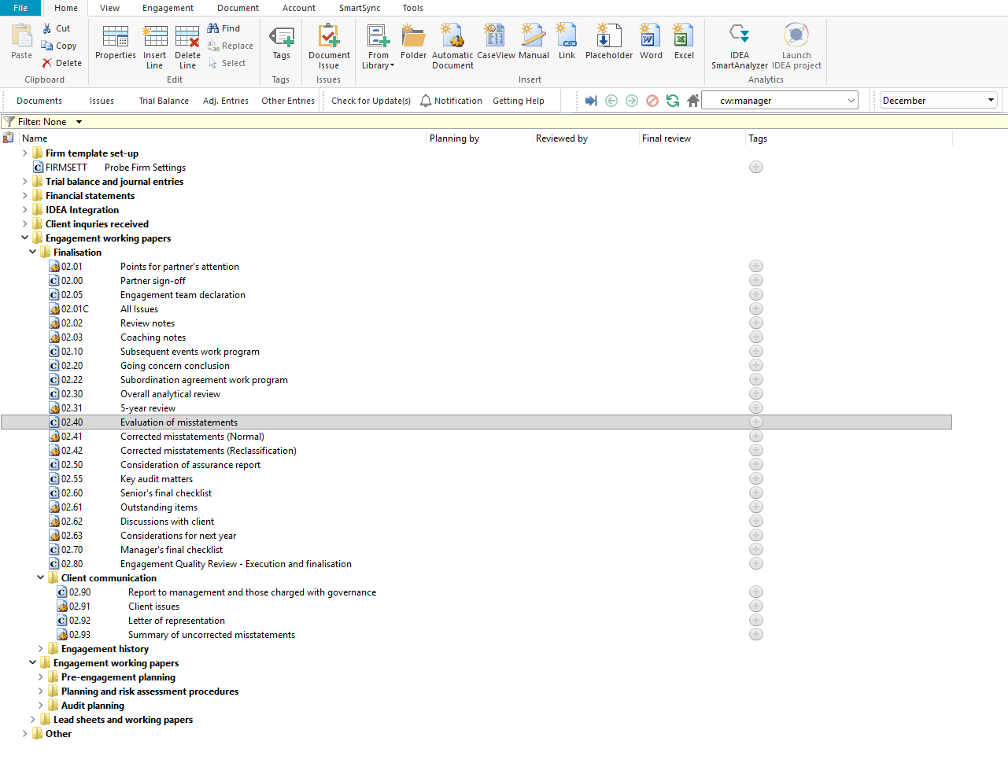

Document content

This document is designed to be an evaluation document that allows the engagement team to reassess materiality and evaluate the misstatements identified during the audit. The document presents five materiality bases with their applicable minimum and maximum percentage parameters and current year values, the overall materiality and performance materiality amounts set during the planning stage, and a conclusion regarding misstatements.

The document addresses the requirements of ISA 450 – Evaluation of Misstatements Identified During the Audit and ISA 320 – Materiality in Planning and Performing an Audit. The following bookmarks are available in the document map to assist you in navigating the document:

Materiality reassessment

Conclusion regarding misstatements
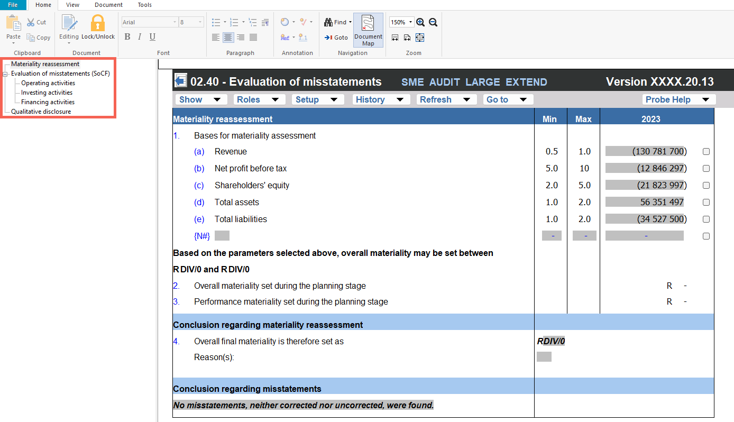

Layout
Column | Input Required | Outcome
Materiality reassessment
Materiality base | No input is required in this column. Displays five pre-populated materiality assessment bases: (a) Revenue, (b) Net profit before tax, (c) Shareholders' equity, (d) Total assets, and (e) Total liabilities, with their corresponding minimum and maximum percentage parameters and current year values. | No impact on the engagement file. Identifies the available bases and percentage ranges for the materiality assessment.
Selection | Select the applicable materiality base by clicking the tick box next to the relevant base. Only one base should be selected. | The overall materiality range is calculated based on the selected base and the applicable minimum and maximum percentage parameters. The calculated range is displayed below the materiality bases.
Overall materiality set during the planning stage | No input is required in this column. Displays the overall materiality amount set during the planning stage of the engagement. | No impact on the engagement file. Presents the planning-stage overall materiality for comparison during the reassessment.
Performance materiality set during the planning stage | No input is required in this column. Displays the performance materiality amount set during the planning stage of the engagement. | No impact on the engagement file. Presents the planning-stage performance materiality for comparison during the reassessment.
Overall final materiality | No input is required in this column. Displays the calculated overall final materiality based on the selected materiality base and the percentage parameters. | Sets the final materiality amount for the engagement. The engagement team must confirm that the final materiality is appropriate.
Reason(s) | Enter the reason for the final materiality amount selected by the engagement team. | No impact on the engagement file. Documents the engagement team's rationale for the final materiality assessment.
Conclusion regarding misstatements
Conclusion | No input is required in this column. Displays a pre-populated conclusion statement regarding misstatements identified during the audit. The conclusion is automatically determined based on the misstatements recorded in the engagement file. | No impact on the engagement file. Provides the conclusion regarding corrected and uncorrected misstatements for the engagement team's evaluation.

Document outcomes

The engagement team must select the applicable materiality base, review the calculated overall final materiality, and document the reason for the final materiality amount. The engagement team must compare the final materiality to the overall materiality and performance materiality set during the planning stage to determine whether the reassessment is appropriate.

The engagement team must review the pre-populated conclusion regarding misstatements to confirm that it accurately reflects the corrected and uncorrected misstatements identified during the audit.

Group Audits

When the engagement type was selected as 'Group Audit Single' or 'Group Audit Multiple', the evaluation of misstatements applies to the group engagement. The engagement team must evaluate misstatements at both the group and component level and consider the impact on the group's overall materiality assessment.

IN CONCLUSION

Features

The following features are available in the document:

Insert or delete a comment, see page F3

Guidance, see page F16

Freeze, see page F19

